Course Recommender System in a Liberal Arts Context

Raphaël Morsomme
University College Maastricht
Zwingelput 4
6211 KH Maastricht
+32496486716
raphael.morsomme@maastrichtuniversity.nl
Sofia Vazquez Alferez
University College Maastricht
Zwingelput 4
6211 KH Maastricht
+31625246406
sofia.vazquezalferez@maastrichtuniversity.nl

ABSTRACT
This paper describes a direct application of topic modelling and sequential rule mining to provide transparent course recommendations to students of the Liberal Arts and Sciences Bachelor from University College Maastricht, based on their academic interests and performance in previous courses. The system is developed to complement academic advising and help students make well informed decisions. We find that course recommendations based on a topic modeling of course descriptions are useful and that sequence mining provides a rough method to control for prerequisites.

Keywords
Education, recommender system, warning, topic model, grade prediction.

INTRODUCTION
The Bachelor in Liberal Arts offered at the University College Maastricht, the Netherlands, is an honors program characterized by an open curriculum. The program allows students to design their curriculum in a fairly free fashion: more than 75% of the educational credits are free, the college offers over 150 courses covering a wide range of topics from artificial intelligence, to conflict resolution and to pop songs, and students can take up to one year’s worth of courses at other departments of the university. This freedom allows students to tailor their curriculum to their own interests, but the large number of courses available makes the selection of courses overwhelming (Surpatean et al, 2012). Firstly, the number of courses offered at the 12 departments of the university is too large for students to have an overview of which ones match their academic interests. Secondly, since each student of the program has a unique curriculum, it can difficult for them to determine if they have covered the necessary prerequisites for a particular course or if the course’s level is too advanced given their academic background. A system that identifies courses matching students’ academic interests and issues a warning for courses too advanced would therefore be extremely beneficial for the students of the Liberal Arts program. Not only does it increase their information position, thereby improving self-advising, but, used as an agenda-setting tool, it also improve academic advising.

Our course recommender system achieves both goals: courses suggestions and warning issuance. To receive course suggestions, the student enters her/his academic interest into the system which returns the 10 courses that best match the student’s interests. In practice, the student selects key words from a predetermined list that represent her/his academic interests. The course recommender system then uses a topic model to identify the courses whose content best matches the topics corresponding to the selected key words (see figure X). To receive warnings, students provide their transcript and indicate which courses they are considering for the following term. The system issues a warning for courses that it identifies as too advanced given current academic background of the student. In practice, the student enters her/his student ID with which the system extract her/his past academic performance and the expertise that she/he has acquired in various topics. From these, the system uses a predictive model to estimate the grade that the student will obtain in the selected courses and issues a warning when the predicted grade is a fail (see figure X).
Furthermore, in order to help the students plan their curriculum in a well-informed way, each course suggestion includes a list of the selected key words that led to it, and each warning issued has a list of preparatory coursework attached to it.
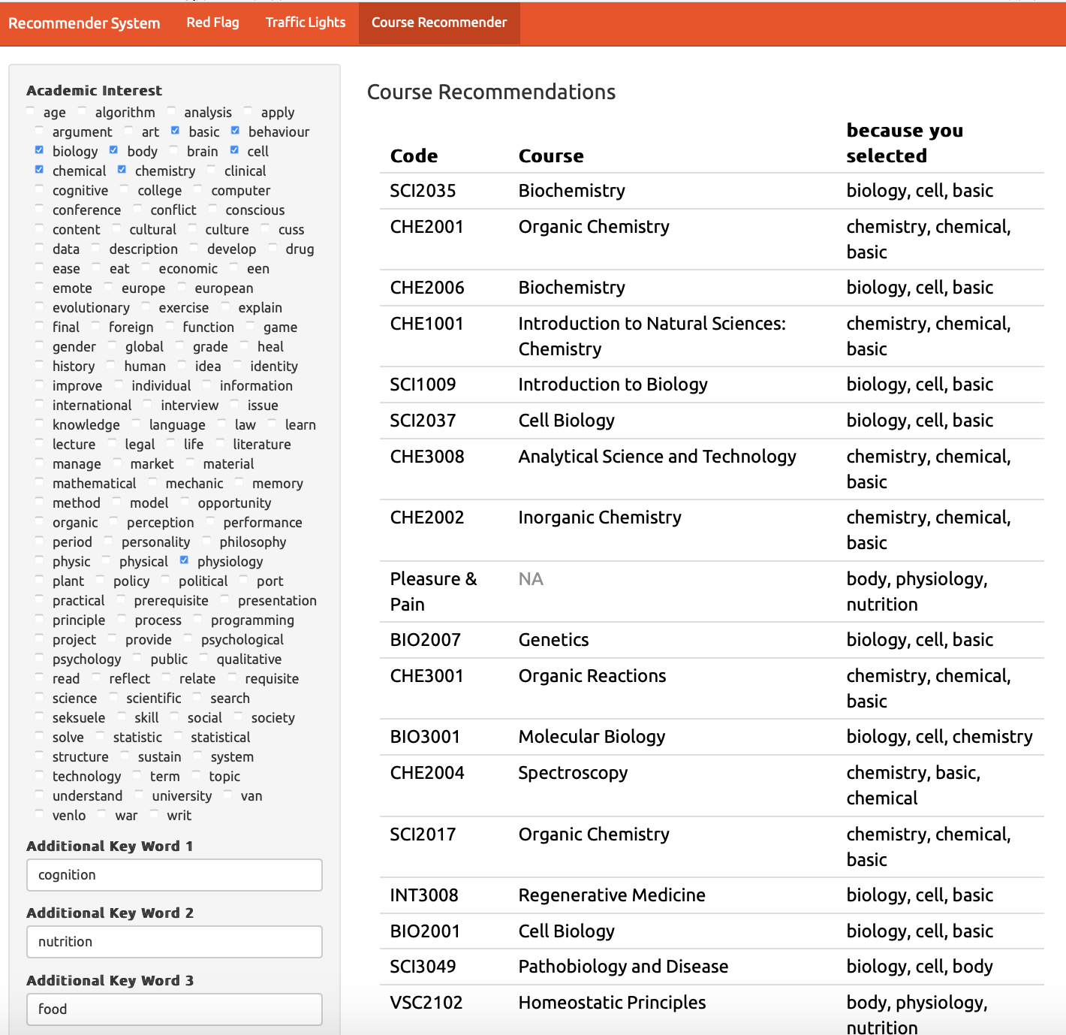
Figure X. Course suggestions in practice.
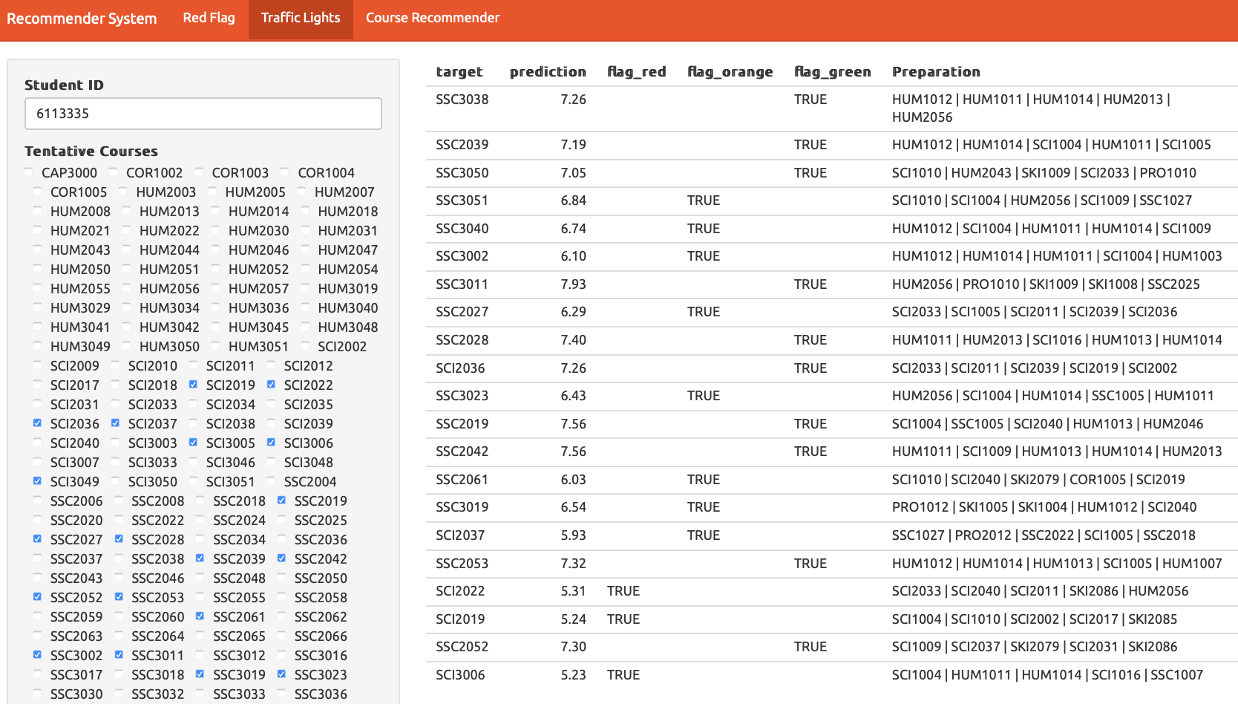
Figure X. Warnings in practice.

RELATED WORK
Identifying courses that are both of interest to the (university) students and of an appropriate level is a task that has recently gained attention in the literature. Gulzar, Leema and Deepak (2018) proposed a recommender system that uses information retrieval techniques to select courses based on student interests. Their system uses key words to search the space of possible courses but tries to improve the quality of the query by finding synonyms and generating N-grams so that the search returns a higher number of courses. Then, an Ontological Model is used to expand the search even further and retrieve courses that are related in the Ontological Model to the previously extracted courses. In this context, an Ontological Model is a knowledge model that represents relationships between concepts of a previously specified domain, such as ‘Computer Science’ (Gulzar, Leema, 2016). The system is considered to be content based because it is the contents of the courses that are matched to the concepts of the ontological model or the key words of the query. In this manner, the recommender system allows the interest of the students to be matched to the contents of the course. However, the system suffers from several drawbacks: first, the domains (e.g. Computer Science or Medicine) from which the ontological models are built must be defined a-priori (Gulzar, Leema, 2016). Second, the recommender system is dependent on a well-built database that is not always available at interested institutions.
Bydžovská (2016), developed a recommender system that takes into account a student’s past performance and interest profile to make course recommendations. Students interests are defined in a narrow sense, that is, a course is considered of interest if a student has taken the course or marked it as a favorite in the university system. Course recommendations based on interest are then made through a collaborative filtering approach: the suggested courses were the most selected courses by other students in the same field of study, or those that were taken by the n-most similar students that had already graduated. To detect risk of failure, Bydžovská (2016) predicted grades of students using classification and regression, or nearest neighbor depending on the course, binned the predicted grades into excellent, good, or bad and then issued warnings accordingly. The main innovation of the system, was that it proceeded to include social behavior and consider courses taught by a favorite teacher or taken by friends of students into the recommendations. Although the system attempts to handle both interest and appropriateness of level for a course, it suffers from a three major disadvantages: firstly, it does not provide the kind of transparent recommendation that would allow students to reflect on their course selection because the content of the course is not explicitly taken into account. Secondly, it does not give students suggestions of how to address their deficiencies. Thirdly, it does allow for a change in student interests, which is particularly important in a liberal arts context where students go through a broad exploratory phase before specializing.
Bakhshinategh, Spanakis et. al, (2017) addressed the issue of recommending courses that helps students overcome their deficiencies whilst accounting for changes over time. They view a study program as a path to obtain graduating attributes (skills, qualities, understandings) and rank the impact that each course has on promoting those graduating attributes for a student who took the course. The ranking is done through self-assessment by students after taking the course. The recommender system then uses collaborative filtering to find courses that score highest on promoting a targeted graduating attribute for a student who wishes to develop it further. Thus, if a student lacks “analytical skills”, the system identifies courses that improve these skills so that a student comes closer to the level of “analytical skills” that is required for graduation. This system can be used to find preparatory courses for other courses by shifting from graduating attributes to attributes required to succeed in a course. The main disadvantage is that the impact of each course is found through self-assessment rather than in a data driven way.
Jang, Pardos and Wei (2019) take a different approach to find preparatory courses by using Recurrent Neural Networks to develop a goal-based course recommender. A student specifies a course that they wish to take, along with the grade they desire to achieve and the system uses their personal course enrollment history and grades to find personalized preparatory courses. Although this approach finds preparatory courses in a data-driven way, it does so at the expense of transparency, which makes a student’s reflective decision making process more difficult and provides no direct insight to academic advising on how to improve the curriculum.
[INSERT LINK TO OUR WORK FITS HERE]
- we extend Bydžovská (2016) ‘s use of student interest by using a topic model.

DATA
We use two types of data: student data and course data.
The student data consists of anonymized course enrollment information. We use the transcripts of the 2,526 students of the liberal arts program between 2008 and 2019 with a total of 79,245 course enrollments. We exclude enrollments with a missing grade, indicating that the student either dropped the course or fail the attendance requirement. In the latter case, the data set contains an observation corresponding to the resit. Figure X presents the student data. Each row contains an anonymized student ID, a course ID, a year and semester, and the obtained grade.
The course data consists of the 2018-2019 course catalogues of 5 departments of Maastricht University: European Studies, University College Maastricht, University College Venlo, Psychology and Science Program. These course catalogues contains a one-page description of 490 courses. Figure X presents the textual data in the tidy format with one row per document-term (Wickham, 2014). We follow common data cleaning procedure in text mining (Meyer, Hornik, & Feinerer, 2008): we tokenize the individual terms, stem them with the Hunspell dictionary and remove common stop words, numbers between 1 and 1,000, and terms occurring less than 3 times in the data set.
Table 1. Example of student data
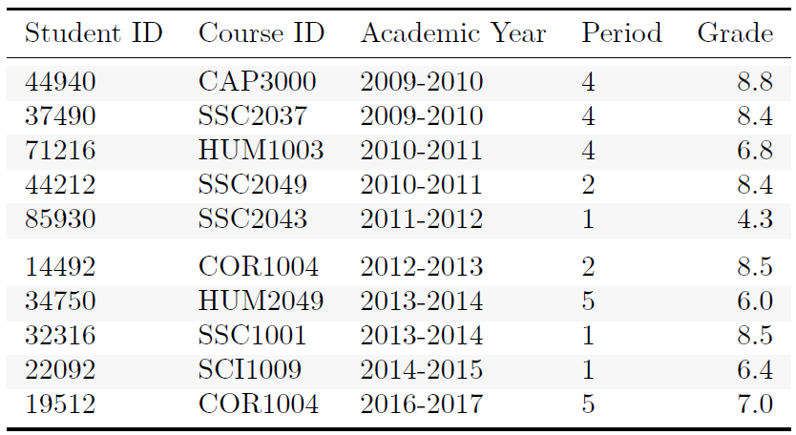
Table 2. Example of course data
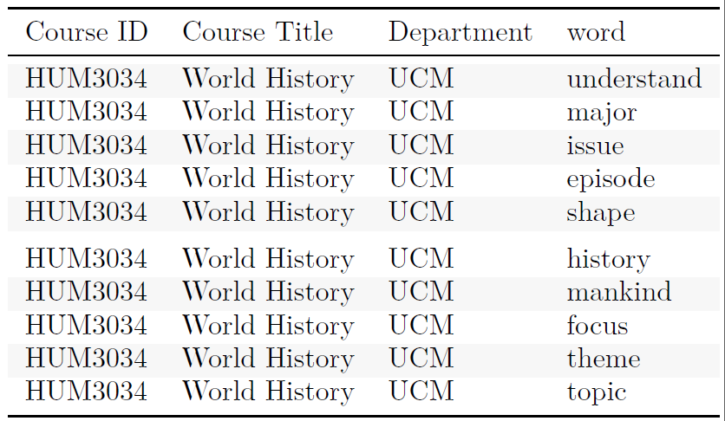

METHODOLOGY

Overview
Figure X presents a diagram of the course recommender system. We start by fitting models on the data. We use the Latent Dirichlet Allocation statistical model to fit a topic model on the course data. The topic model is then used to derive the students’ level of expertise in the topics from the course they have taken as indicated by the student data. Together with their academic performance i.e. their GPA, the topic expertise of the students are the inputs for the predictive models for grade that we fit to each individual course and regularize with the lasso penalty.
We use these models to generate intermediate results from the user’s input. The topic model is used to derive the student’s academic interests from the key words that she/he has selected. The predictive models estimate the grades that the student will obtain in the course she/he has entered into the system.
The system’s output is based on these intermediate results. The course suggestions consists of the 10 courses whose content best matches the student’s academic interest in terms of Kullback-Leibler deviance. Warnings are issued when the predicted grade is a fail. For each course concerned by a warning, we indicate the 5 courses whose content has the best preparatory value according to the predictive model.

Topic Model
We use the Latent Dirichlet Allocation (LDA) generative probabilistic model and the Gibbs sampling algorithm to fit a topic model to the course data.
LDA conceptualizes topics as a probability distribution over a finite set of words (in this case, the vocabulary of the course data), and a document (i.e. a course description) as a sequence of N words, where each word was generated by drawing from a probability distribution over topics specific to that document. Thus, each word belongs to all topics but with different probabilities, and all topics are present in each course but with different weights. In technical terms, the LDA model generates a document as follows. First, the word distribution β for each topic is determined by β ~ Dirichlet(δ) and the topic weights θ for each document are determined by θ ~ Dirichlet(α). Second, each of the N words is chosen but choosing a topic z ~ Multinomial(θ) and then choosing a word from a multinomial probability distribution conditioned on the topic z.
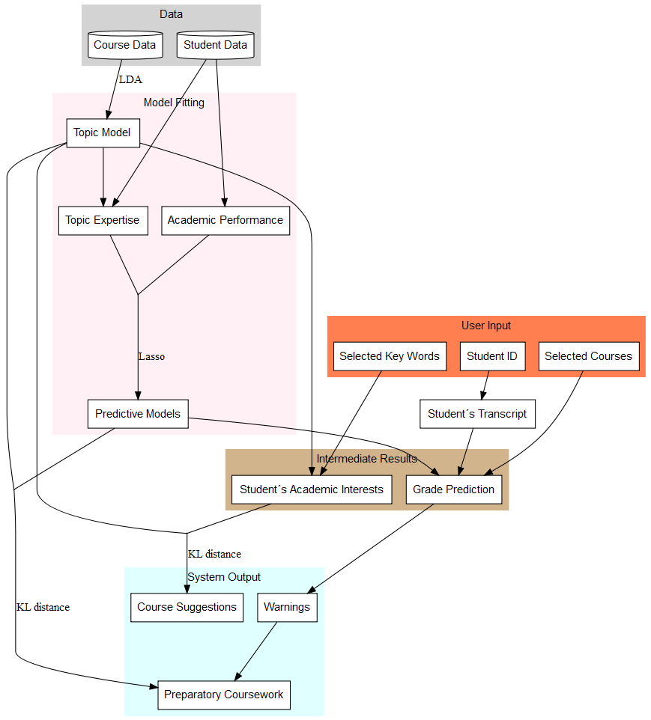
Figure X. Diagram of the course recommender system.
LDA conceptualizes topics as a probability distribution over a finite set of words (in this case, the vocabulary of the course data), and a document (i.e. a course description) as a sequence of N words, where each word was generated by drawing from a probability distribution over topics specific to that document. Thus, each word belongs to all topics but with different probabilities, and all topics are present in each course but with different weights. In technical terms, the LDA model generates a document as follows. First, the word distribution β for each topic is determined by β ~ Dirichlet(δ) and the topic weights θ for each document are determined by θ ~ Dirichlet(α). Second, each of the N words is chosen but choosing a topic z ~ Multinomial(θ) and then choosing a word from a multinomial probability distribution conditioned on the topic z.
Gibbs sampling is a Monte Carlo Markov Chain (MCMC) technique for successively sampling conditional distributions of variables whose distribution over states converges to the true distribution in the long run (Gelman et al., 2013). Gibbs sampling generates posterior samples by sweeping through each variable and sampling from its conditional distribution when the other variables are fixed to their current values. If the documents in our course data were generated with the LDA model, we use Gibbs sampling to learn the distributions β and θ (Phan et al., 2008). In this case, δ and α are the prior distributions for Gibbs sampling, acting as hyper-parameters that respectively affect how sparse the distributions of words in topics and topics in documents are. Gibbs sampling picks each word in the vocabulary and estimates the probability of assigning the current word to each topic conditioned on the topic assignments of all other words. With this conditional distribution, given a document, a topic is sampled and assigned as the new topic assignment for the current word. Then, with the distribution of words per topic, we compute the conditional probability of the topics given an observed document. Since Gibbs sampling is a MCMC, the sampled distribution approximates the target distribution if the number of iterations is large (Gelman et al., 2013), enabling us to infer β and θ.
This procedure requires that we fix a-priori the number of topics (k) to be inferred. We trained 30 models with a number of topics ranging from 5 to 150 by 5. We set α to 50/k and δ to 0.1 as suggested by Griffiths & Steyvers (2004). For Gibbs sampling, we run 6,000 iterations with a burn in of 1,000 iterations, and sample every 100 iterations. To explore the model space, we use random initializations and the best model over all runs with respect to the log-likelihood is returned. We select the number of topics yielding the model with the largest log likelihood (Griffiths & Steyvers, 2004). The model with 65 topics has the maximum log likelihood. In order to obtain an even more accurate model, we refit it with more iterations (16,000 iterations with a burn in of 2,000 iterations; the other parameters are kept the same).
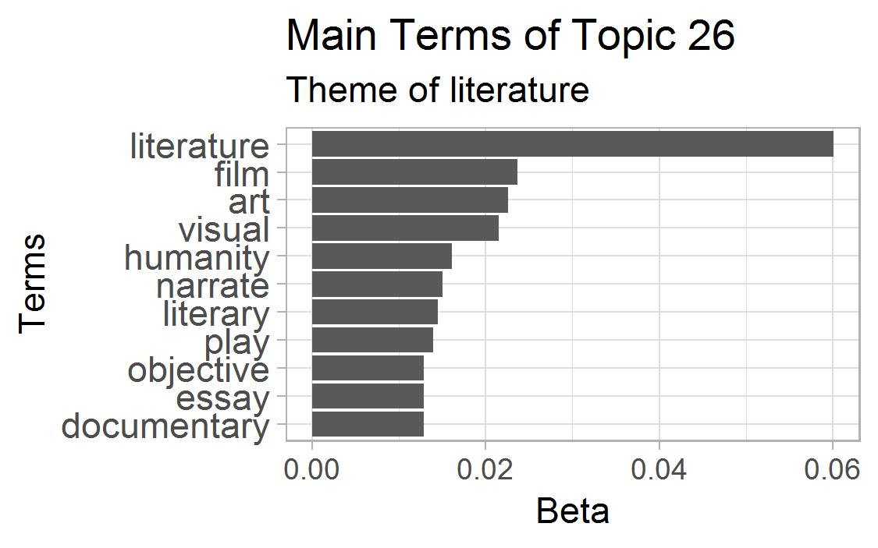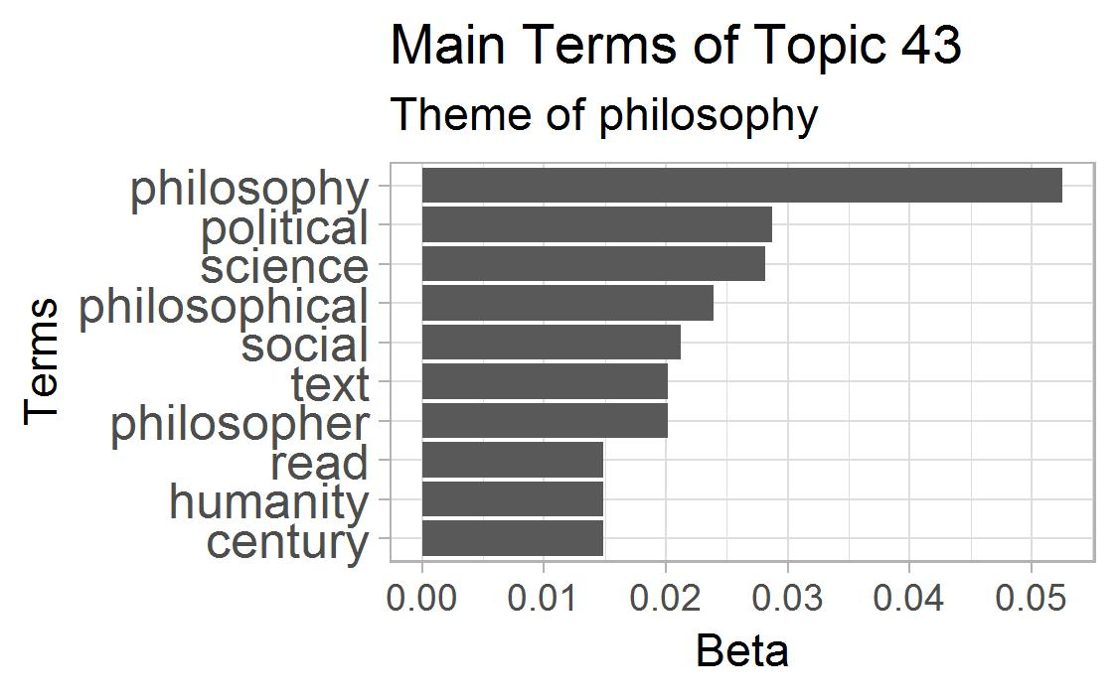
Figure X. Term distribution in two topics.
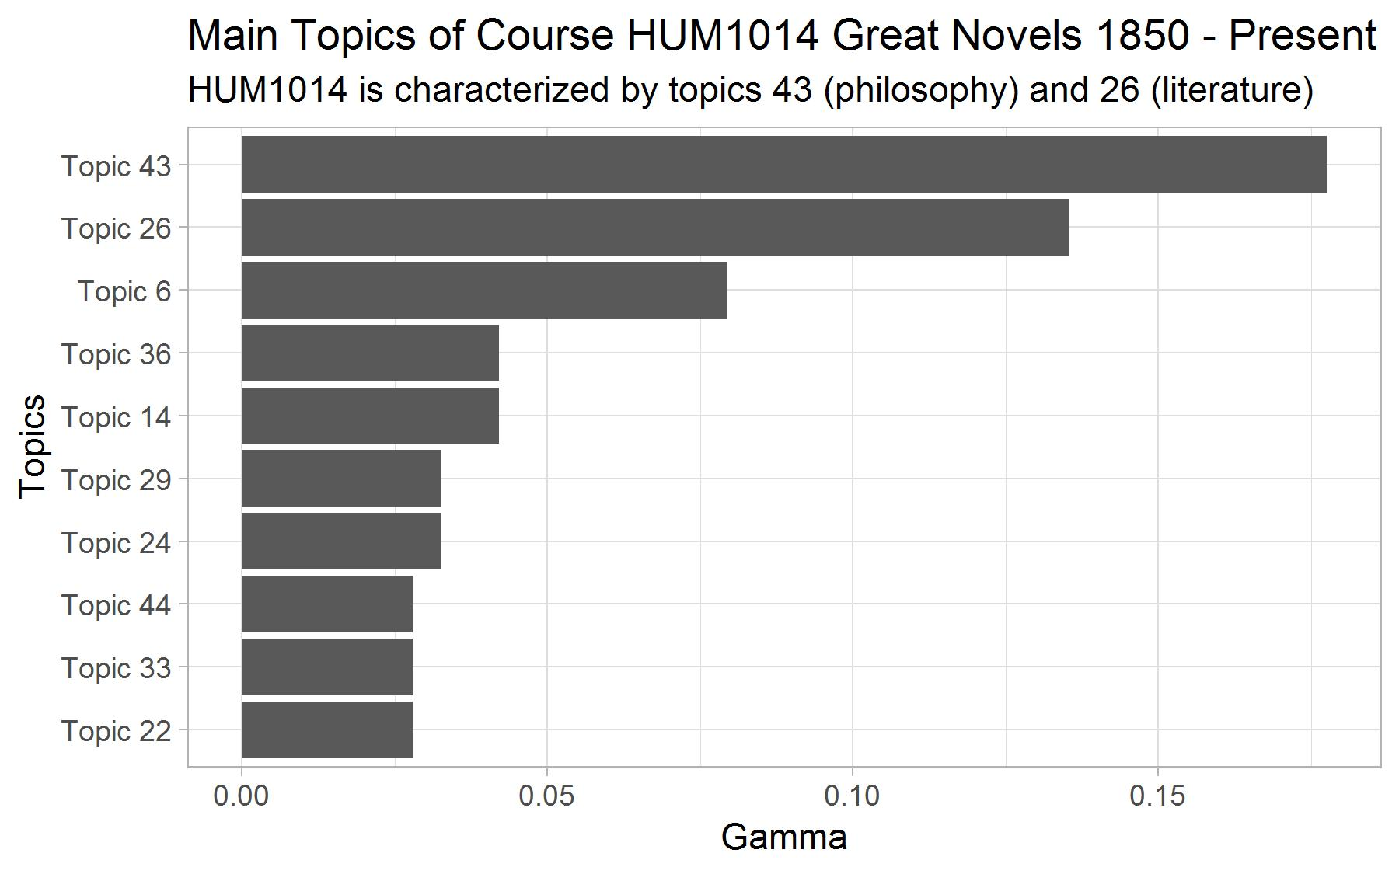
Figure X. Topic distribution in a course.
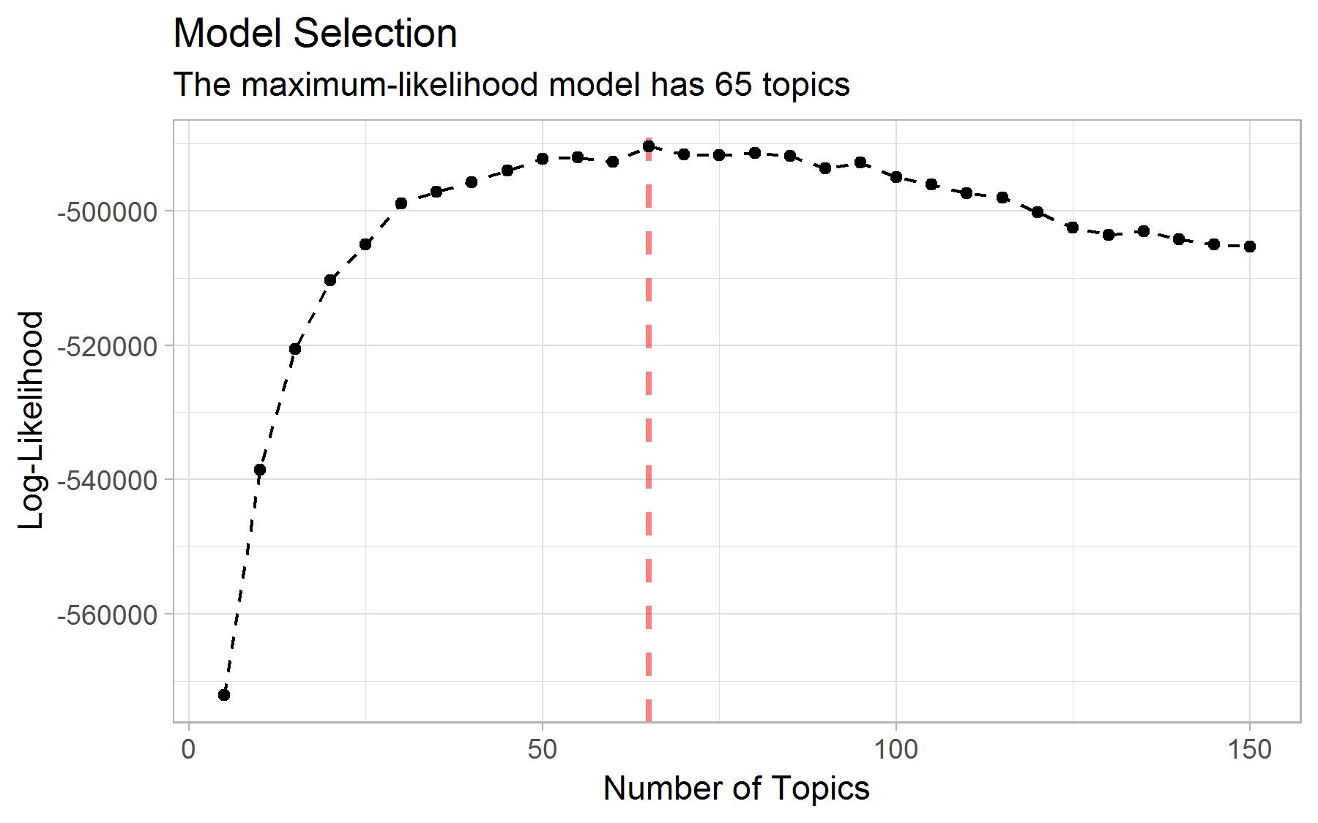
Figure X. Model Selection based on log-likelihood.

Warnings
We fit a predictive model for grade for each of the 132 courses currently offered at the college that have had more than 20 student enrollments since 2008. The model is a lasso-regularized linear regression model (Tibshirani, 1996). The set of predictors consists of students’ past academic performance and their level of topic expertise at the start of the course. Students’ past academic performance consists of 6 variables corresponding to their general GPA and their concentration-specific GPA (humanities, natural sciences, social science, skills and projects). Students’ topic expertise consists of a set of 35 variables (one per topic of the topic model) which indicate how much knowledge of the topic the student has acquired through his curriculum. Topic expertise can be regarded as an approximation of the skills acquired by the student. Concretely, a topic expertise variable corresponds to the sum of the topic’s importance in the courses taken by the student (as estimated by the topic model) weighted by the grades. The assumption is that students who obtain 10/10 in a course have acquired all the topic-related knowledge present in the course while those obtaining 5/10 have only acquired half of it. Figure X shows a toy example of the contribution of individual courses towards a student’s topic expertise.
Since the number of predictors is large, we regularize the models to avoid overfitting. We use the lasso penalty to shrink the coefficient estimates (Tibshirani, 1996). For each model, we use 10-fold cross-validation (CV) to find the lasso tuning parameter λ that minimizes the CV mean absolute error, a more robust loss function than the squared error (Hastie et al., 2009). Figure X presents the distribution of the CV mean absolute error for the 132 prediction models. The model for the course PRO2004 Academic Debate has the smallest prediction error (0.38 grade point) and the model for SCI3006 Mathematical Modelling the largest (1.74 grade point). The mean CV error weighted by the number of students enrolled in the course is 0.77, the median is 0.77 and the standard deviation is 0.28.
Table 3a. Toy example: topic distribution in 3 courses
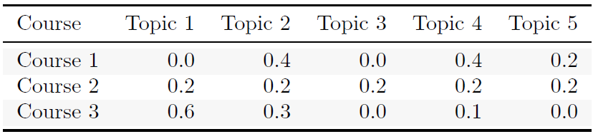
Table 3b. Toy example: transcript
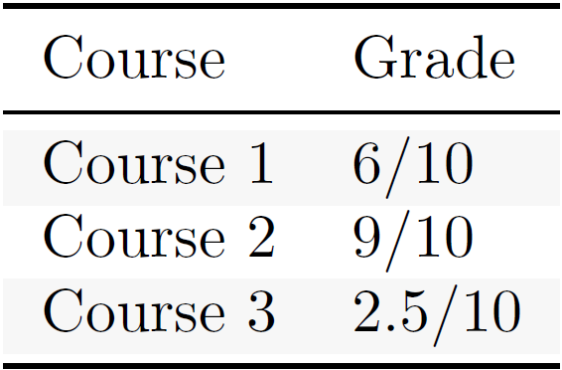
Table 3c. Toy example: course contribution to topic expertise
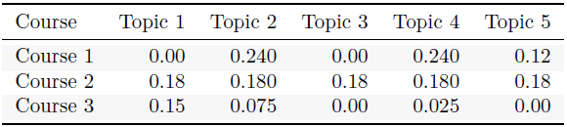
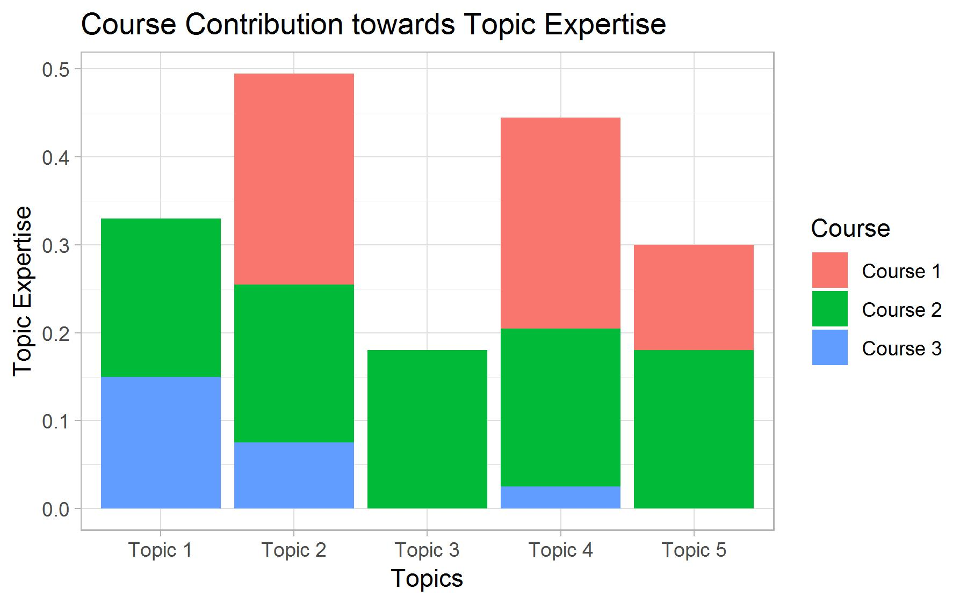
Figure X. Toy example: course contribution to a student’s topic expertise. We use these variables to predict grade.
To receive a warning, the user enters into the system her/his student ID and a list of courses that she/he is considering for the coming term. The system uses the student ID to extract the student’s transcript, from which her/his past academic performance and topic expertise are established. The predictive models of the selected courses then use these variables to predict the grades the student will receive if she/he enrolls in the selected courses. A warning is issued if the model predicts a fail grade.
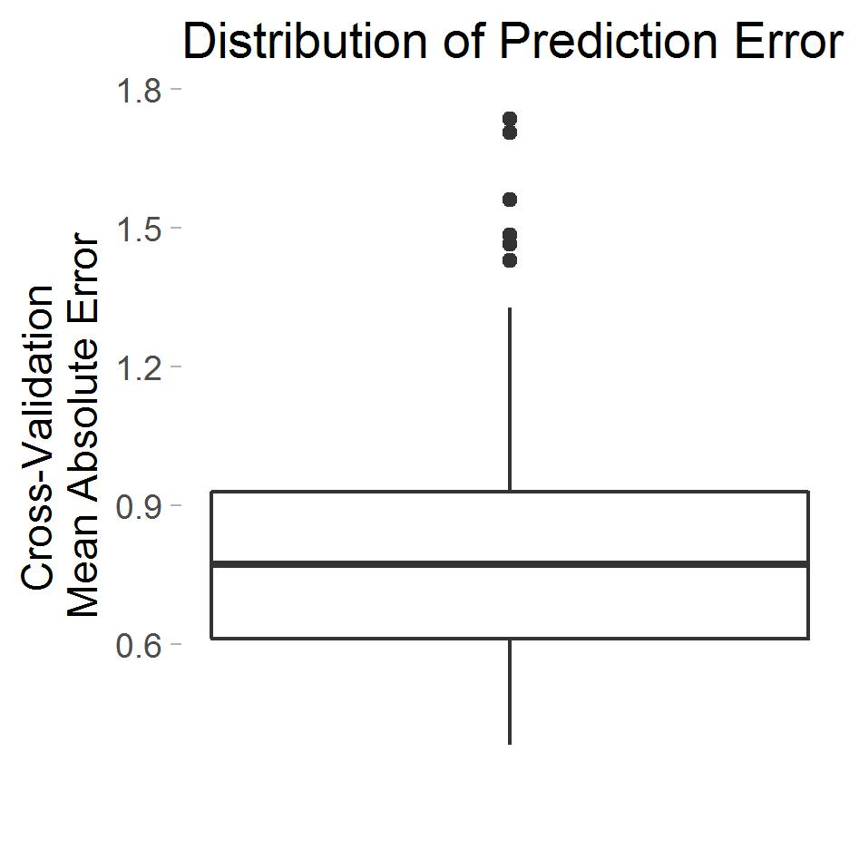
Figure X. Distribution of the cross-validation mean absolute error in the 148 predictive models.

Rule-based Warnings (Exclude to gain space?)
We investigated an alternative approach for warnings based on association rules. We used the CSPADE algorithm (REF) to identify sequences in the students transcripts of the type <fail course A> => <fail course B> and <not take course A> => <fail course B> and considered rules with a support superior to 10 students, a confidence superior to 0.4 and a lift superior to 1.1. Warnings were issued when a student indicate that they considered taking a course for which one the selected rules indicates that she/he is likely to fail it.
Although this approach is very transparent, which motivated its initial adoption, it turned out to be unsuitable to our case. First, given the small size of our sample and the fact that relatively few students fail courses at the college, only 21 rules met the criteria. Second, this approach ignores the fact that skills can be acquired in several courses.
To tackle the first issue, we considered a relaxed version of the rules that substitutes a <fail course A> with a <obtain less than 6.5 in course A>. This increased the number of rules meeting the criteria to 185. Yet, the second issue remained and led us to consider a regressive predicting model that uses topic expertise as a proxy for skills that a necessary to perform well in a course.

Course Recommendation
To provide course recommendations, we use the Kullback-Leibler distance to identify courses whose content best match the academic interests of the students. A student’s academic interest profile consists of a numeric vector indicating the interest of the student in each of the topics. It corresponds to the sum of the contribution of the selected key words to the topics. In order to assist students in the selection of key words, 10 terms are preselected based on their topic expertise profile (as defined in section 4.3). The Kullback-Leibler distance is an asymmetric measure of the difference between two probability distributions. We use it to estimate the similarity between the normalized academic interest profile of the student and a course’s topic distribution. The system returns the 10 courses with the smallest such distance. To make the system as informative and transparent as possible, each recommendation includes the three key words selected by the student with the most relevance to the course. We approximate the latter with the sum of the term’s importance across topics weighted by the probability of the topics in the course.

Preparatory Coursework
In order to help student plan their curriculum, each warning is accompanied by a list of preparatory course work. Similarly to the warnings, we fit a lasso-regularized predictive linear regression model for each course which, this time, takes as input students’ topic expertise. Large positive coefficient estimates indicates that of good knowledge of the associated topics is associated with a larger grade in the course. For each course, the preparatory coursework consists of the 5 classes whose topic distribution has the smallest KL distance to the course’s predictive model’s normalized coefficient estimate

RESULTS
Our course recommender system has been used by. Course suggestion
warning issuance
preparatory coursework

FUTURE WORK
Our course recommender system is a work in progress. This paper presents its current state. We are currently expanding the course data to course manuals, 20-page document offering a detailed description of a course’s content, and in the future, we plan to integrate the academic literature of each course e.g. academic articles, textbook chapters and any material covered in the course. Since the topic model has a fundamental place in the system, we are also improving the topic model by considering STM (expand) (REF). any improvement should

ACKNOWLEDGMENTS
Our thanks to the University College Maastricht, the Institute of Data Science, Maastricht University, and the Department of Data Science and Knowledge Engineering, Maastricht University, in particular to Evgueni Smirnov, and Peter Vermeer for supporting this project with their expertise.

REFERENCES
- Bakhshinategh, B., Spanakis, G., Zaïane, O. R., & ElAtia, S. (2017). A Course Recommender System based on Graduating Attributes. In CSEDU (1) (pp. 347-354).
- Blei, D. M., Ng, A. Y., & Jordan, M. I. (2003). Latent dirichlet allocation. Journal of machine Learning research, 3(Jan), 993-1022.
- Bydžovská, H. (2016). Course Enrollment Recommender System. International Educational Data Mining Society.
- Gelman, A., Stern, H. S., Carlin, J. B., Dunson, D. B., Vehtari, A., & Rubin, D. B. (2013). Bayesian data analysis. Chapman and Hall/CRC.
- Griffiths, T. L., & Steyvers, M. (2004). Finding scientific topics. Proceedings of the National academy of Sciences, 101(suppl 1), 5228-5235.
- Gulzar, Z., Leema, A. A., & Deepak, G. (2018). PCRS: Personalized course recommender system based on hybrid approach. Procedia Computer Science, 125, 518-524.
- Gulzar, Z., & Leema, A. A. (2016). An ontology based approach for exploring knowledge in networking domain. In 2016 International Conference on Inventive Computation Technologies (ICICT) (Vol. 1, pp. 1-6). IEEE.
- Hastie, T., Tibshirani, R., & Friedman, J. (2009). The elements of statistical learning: data mining, inference, and prediction, Springer Series in Statistics.
- Hornik, K., & Grün, B. (2011). topicmodels: An R package for fitting topic models. Journal of Statistical Software, 40(13), 1-30.
- Jiang, W., Pardos, Z. A., & Wei, Q. (2019, March). Goal-based Course Recommendation. In Proceedings of the 9th International Conference on Learning Analytics & Knowledge(pp. 36-45). ACM.
- Kullback, S., & Leibler, R. A. (1951). On information and sufficiency. The annals of mathematical statistics, 22(1), 79-86.
- Meyer, D., Hornik, K., & Feinerer, I. (2008). Text mining infrastructure in R. Journal of statistical software, 25(5), 1-54. URL http://www.jstatsoft.org/v25/i05/.
- Phan, X. H., Nguyen, L. M., & Horiguchi, S. (2008). Learning to classify short and sparse text & web with hidden topics from large-scale data collections. In Proceedings of the 17th international conference on World Wide Web (pp. 91-100). ACM.
- Surpatean, A., Smirnov, E., & Manie, N. (2012). Master orientation tool. In Proceedings of the 20th European Conference on Artificial Intelligence (pp. 995-996). IOS Press.
- Tibshirani, R. (1996). Regression shrinkage and selection via the lasso. Journal of the Royal Statistical Society: Series B (Methodological), 58(1), 267-288.
- Wickham, H. (2014). Tidy data. Journal of Statistical Software, 59(10), 1-23. doi:10.18637/jss.v059.i10.

